University of Engineering and Technology, Lahore
Department of Computer Science



Project Report

Submitted by:
ALI FAYYAZ (2025-CS-76) secB alifayyaz6397@gmail.com
ABU BAKAR(2025-CS-73) secB abubakr199972@gmail.com

Submitted to:
Sir Waqas Ali

Course:
CS-101: Discrete Mathematics

DATED:
26-Dec-2025

PROJECT REPORT

- Project Title
Zero Knowledge Proof Authentication System (Based on Schnorr Protocol)

- Chosen Track
Track 5: Number Theory Applications

- Overview
This project implements a Zero Knowledge Proof (ZKP) authentication system based on the Schnorr protocol. The system allows a prover to verify identity without revealing the secret key, using modular arithmetic and Discrete Logarithm.It uses a 3-way Handshake to prove identity(commintment-challenge-response).

- Summary
Problem and Significance:
In traditional authentication systems, secret information such as passwords or private keys is often stored in database, making systems vulnerable to interception, and data breaches when hacker attacks.
Project Objective:
The objective of this project is to design and implement a Zero Knowledge Proof authentication system using the Schnorr protocol. The system demonstrates how a user (prover) can prove possession of a secret key without ever revealing it to the verifier.
Approach and Methodology:
The project is implemented in C++ using 128-bit arithmetic to handle large numbers safely. It follows the classical Schnorr identification protocol. It is divided into multiple phases: It verify the arthemetic numbers are safe or not, then prover commitment, verifier challenge, prover response, and final verification. Miller–Rabin primality test is used to prove that a modulus is prime, which is essential for cryptographic correctness.Otherwise it will lead to the authentication failure.
Key Achievements:
• Successful implementation of a Schnorr-based Zero Knowledge Proof protocol
• Secure modular exponentiation using overflow-safe arithmetic
• Probabilistic primality testing using Miller–Rabin algorithm
• Clear phase-wise verification showing mathematical correctness and show all the mathematical steps of the calculation.
• User friendly CMD based Interface with proper input and other Instructions.
Educational Importance:
This project shows that modular arithmetic is not a subject only but it is the backbone of the modern authentication systems and bridges cbstracts core discrete mathematics concepts with real-world cryptographic applications.

- Technology Stack & Libraries Utilized
Programming Language:
C++ Chosen for its performance, and support for custom data types such as 128-bit integers.
Libraries Used:
• <iostream>
For standard input/output operations.
• <cmath>
Use to calculate-brute force time and mathematical operation .
for mathematical operation
• <string>
Use to handle 128 bit integer as a string.
• <algorithm>
Use specifically for reverse(). so 128 bit integer string converted back to integer.
• <windows.h>
Use for formatting and console colors.
• <iomanip>
Use to format the output of deciaml numbers, ensuring precison.
Development Environment:
Visual Studio Code with GCC compiler on Windows

- List of Features
Core Features:
• Prime Modulus Verification – Uses Miller–Rabin test to verify prime number.
• Secure Modular Multiplication – Prevents overflow during large multiplication of integers.
• Modular Exponentiation – Efficient calculations using binary exponentiation.
• Zero Knowledge Authentication – Implements Schnorr protocol verification Protocol.
Enhancement Features:
• Strength Analysis – Estimates brute-force of secrets and modulus.
• CMD-Based Interface – Step-by-step protocol visualization.
• Calculations - show step by step mathematical operations.

- Mathematical Foundations
The project is based on core concepts from discrete mathematics and number theory:
• Modular Arithmetic: For integers a, b, and modulus m, modular arithmetic defines equivalence classes where computations are performed modulo m.
• Prime Numbers: A prime modulus ensures that the multiplicative group modulo m has desirable algebraic properties necessary for cryptographic security.
• Fermat’s Little Theorem: If m is prime and gcd(a, m) = 1, then a^(m−1) ≡ 1 (mod m).It is used to find whether a numebr is prime or not.
• Discrete Logarithm Problem: Given y = g^x mod m, computing x is not feasible computationally for large m. The security of Schnorr protocol relies on this hardness.The Hacker never calculates the x if modulus and x are selected properly.
• Zero Knowledge Proof Property: The verifier never knew anything about the secret x except that the prover possesses it.

- Examination of Key Functions / Methods
8.1 stringTo128(string s)
Purpose:
Converts a numeric string into a 128-bit integer to support large cryptographic values.
Algorithm:
• Initialize result to 0
• For each digit character, multiply result by 10 and add digit value
Time Complexity: O(n) Space Complexity: O(1)

8.2 mulmod(a, b, m)
Purpose:
Performs safe modular multiplication without overflow.
Algorithm:
• Uses repeated doubling and modular reduction
• Adds a to result when the current bit of b is 1.

8.3 power(base, exp, mod)
Purpose:
Efficiently computes modular exponentiation.
Algorithm:
• Binary exponentiation
• Uses mulmod for safe multiplication

8.4 millerRabin(n)
Purpose:
Checks whether a number is prime using a probabilistic algorithm.
Algorithm:
• Decomposes n−1 into 2^r · d
• Tests multiple bases for compositeness

8.5 Final Verification
Verification Equation:
g^s mod m = R · y^e mod m
Correctness: If the prover follows the protocol honestly, then both sides of the equation agree to the same value, proving identity without revealing the secret.

- Limitations
• Relies on user-provided parameters, which may be weak if not chosen correctly.
• Miller–Rabin test is probabilistic, not deterministic.It is not 100% accurate.

- User Interface
10.1 Interface Overview
The system uses a command-line interface with a phase-based structure. Each phase represents a step of the Schnorr protocol, improving clarity and educational value.
10.2 Screen-by-Screen Documentation:
• Phase 1: System Configuration – Inputs modulus and secret key
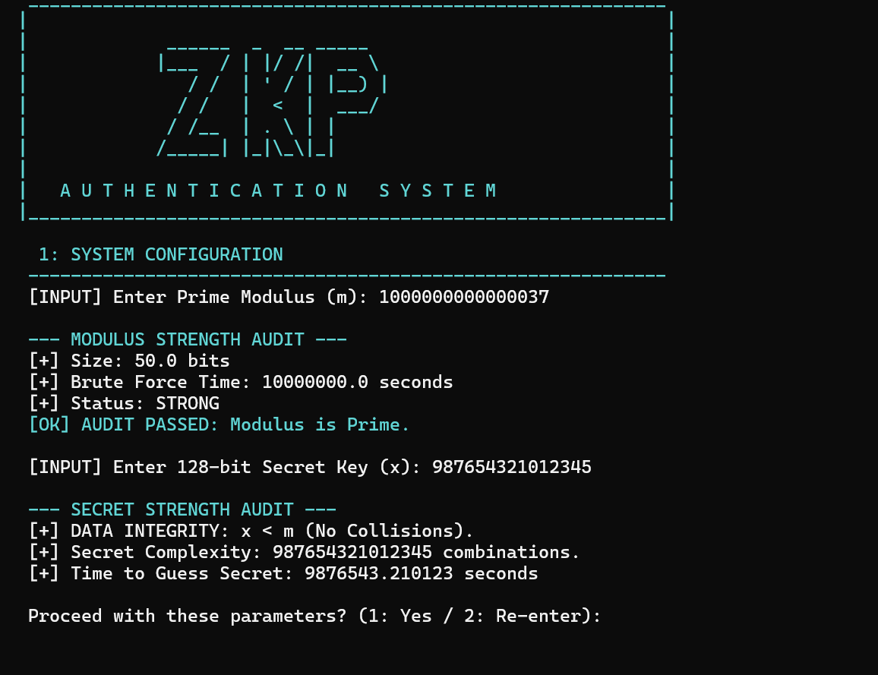
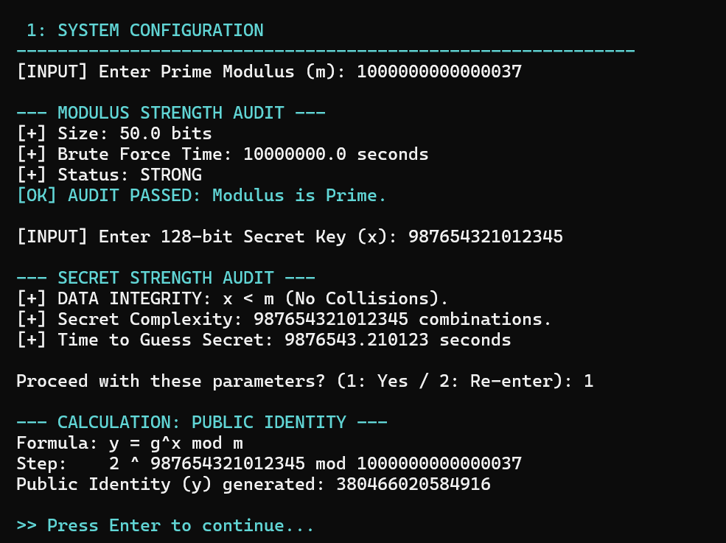
• Phase 2: Prover Commitment – Generates commitment R
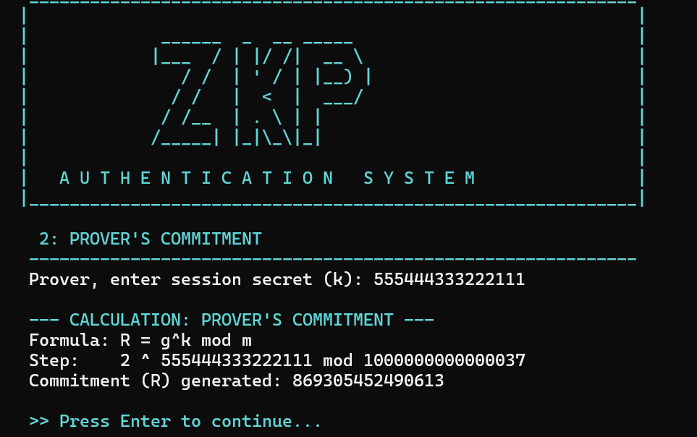
• Phase 3: Verifier Challenge – Accepts challenge e .
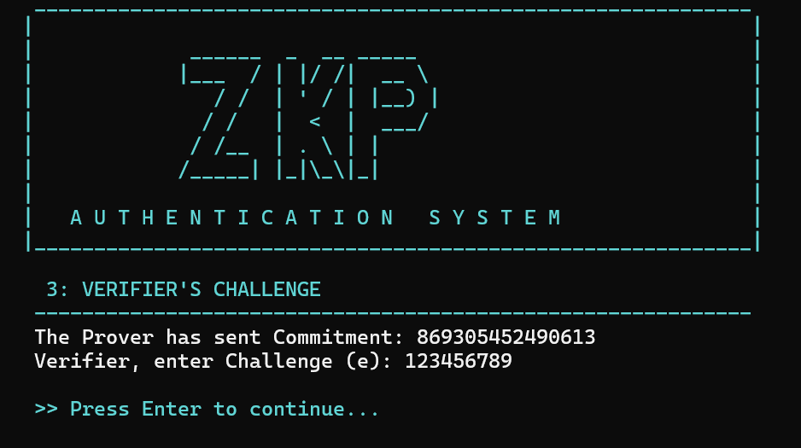
• Phase 4: Prover Response – Computes response s
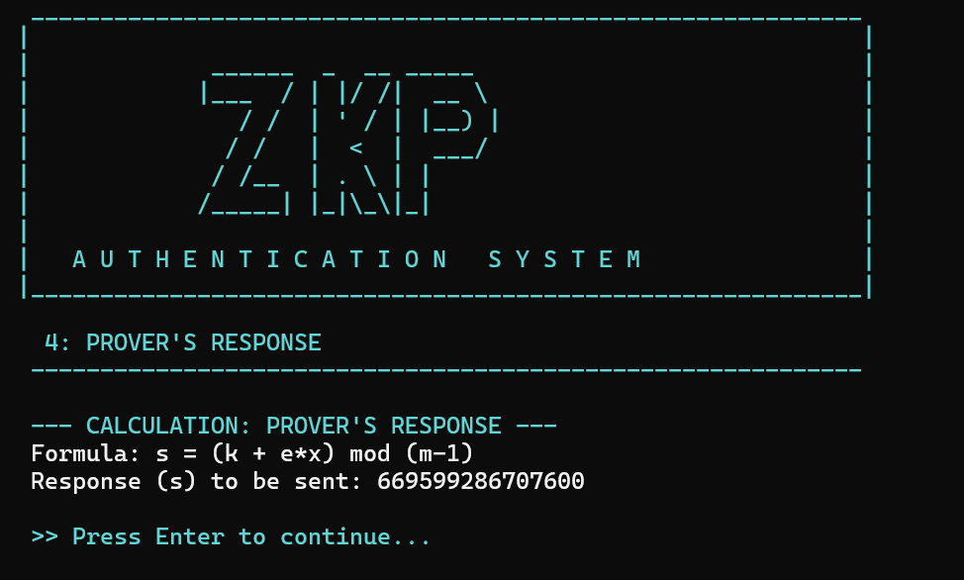
• Phase 5: Final Verification – Confirms authentication result
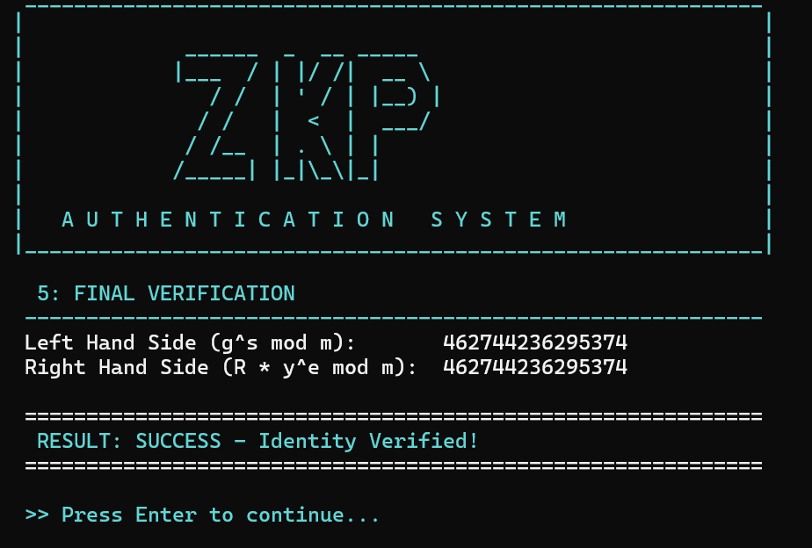
10.3 Sample Test Case:
Input: Prime m = 1000000007 Secret x = 123456
Output: Authentication successful Status: Pass

- Future Improvements
• Graphical User Interface (GUI)
• Fixed cryptographic parameter generation
• Larger key sizes (256-bit or higher)
• Network-based prover-verifier simulation
• Deterministic primality testing

- Conclusion
This project successfully demonstrates a Zero Knowledge Proof authentication system based on the Schnorr protocol. It highlights the importance of number theory in secure authentication while strengthening the understanding of modular arithmetic, primes, and cryptographic protocols. The project effectively connects discrete mathematics theory with real-world security applications.

- References & Learning Sources
• Rosen, K. H. Discrete Mathematics and Its Applications, 8th Edition

REPOSITORY LINK:
https://github.com/alifayyaz6397-ctrl/ZKP-authentication-system-

LINKDIN LINK:
https://www.linkedin.com/posts/ali-fayyaz-01b5a037b_excited-to-share-my-latest-project-zero-activity-7414712792974508033-UaFp?utm_source=share&utm_medium=member_android&rcm=ACoAAF3hlhcBs1sqCSxjQKh3eKJ4OIHtsXbslVw

